ECE 281/383 Vivado Installation

# Overview

This document shows you how to install and license a copy of Xilinx Vivado, along with installing the required board support files. We will be installing Version 2018.2. The system will ask you if you want to upgrade to the latest, but do not accept.

# What you need before starting

1. **Hard disk space** – Plan on the installation requiring approximately 32 GB.
2. **Installation files** (approximately 18GB) – Provided in class with an external hard drive. You do not need to copy them to your computer; you can run them from the hard drive.
   1. **Not required if only adding SDK to a previous installation**
3. **Admin access** – make sure your cadet admin account is available
4. **Time** – Plan on *at least* 30 minutes

# Vivado Installation

If you are simply adding SDK or other features to a previous Vivado installation, click on Add Devices or Design Tools 2018.2 in your Windows Start Menu.

Otherwise, navigate to the Vivado installation files on the provided external hard drive and **run xsetup.exe** in the Vivado_2018.2 folder (admin privileges required). Optionally, you can instead download roughly 18GB of installation files.

In both cases, you should see a lovely splash screen like the below image. Take a one minute nap while the installer loads. Cancel the request to poke a hole in your firewall, if any should pop up.



Users upgrading Vivado can now skip to the Edition Selection on page 3.

For new installs, **Click** **Continue** to install 2018.

**Click Next** at the following screen.

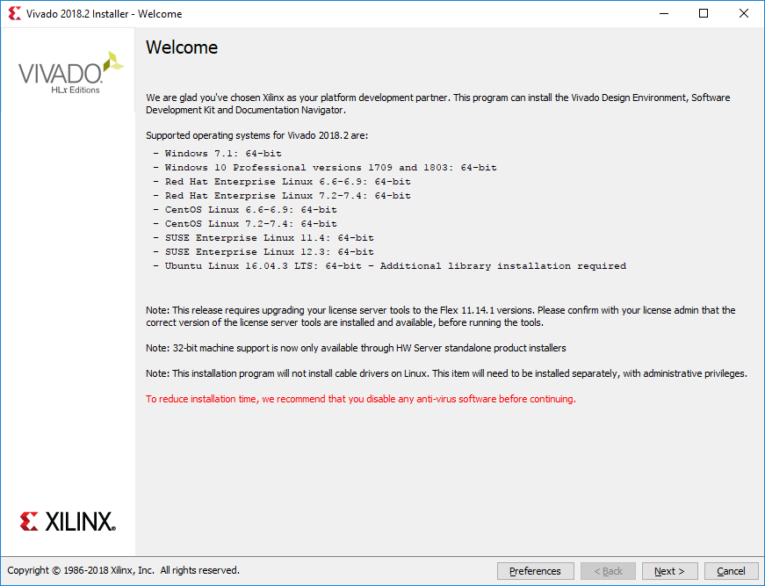

**Check “I Agree”** for all of the terms so you can be owned by lawyers if anything happens. Then **Click Next**.

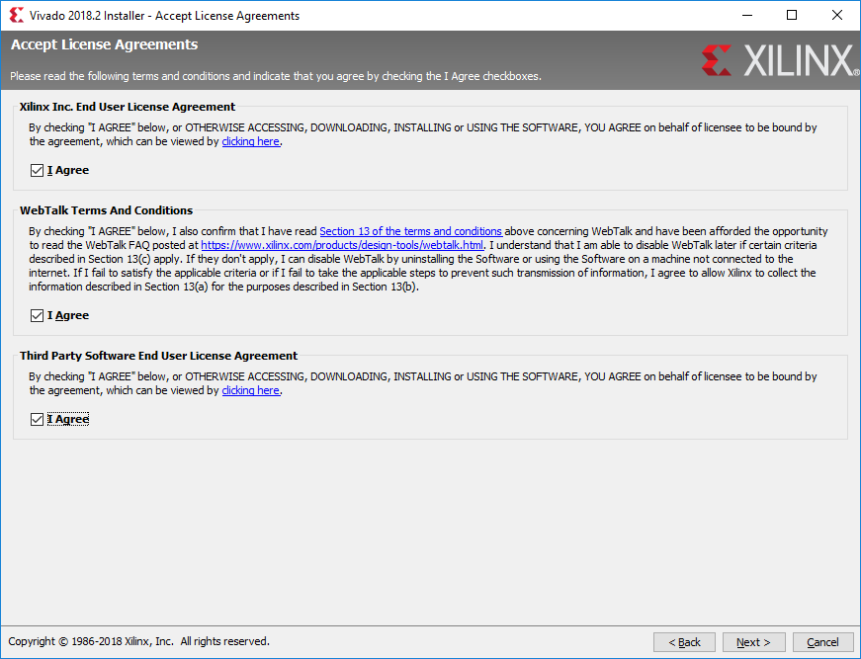

Select the Vivado HL WebPACK Edition and click **Next**.

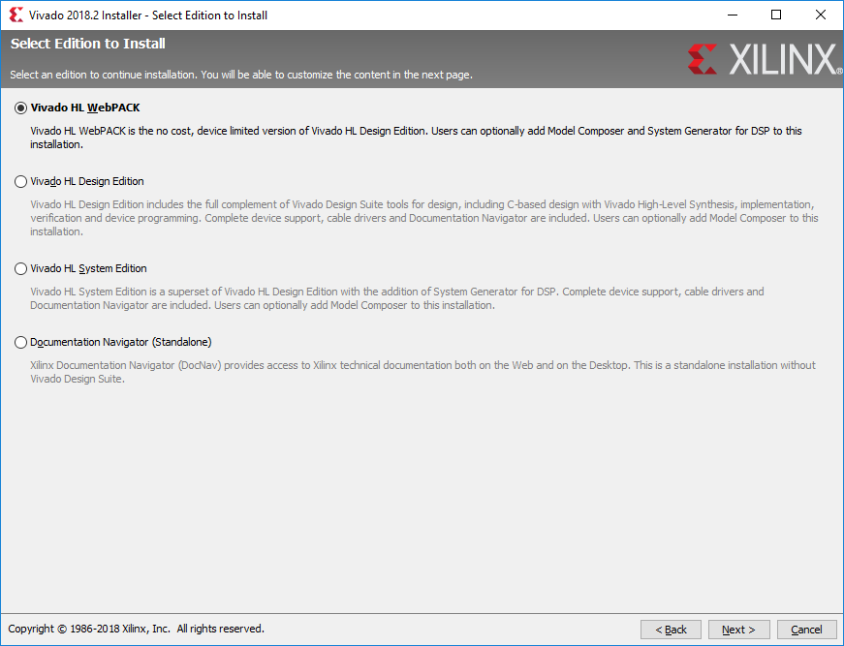

Notice that over 34 GB are required for the install! Following the directions below should reduce this significantly. Unfortunately, the required SDK adds another 12 GB…

* Check Software Development Kit (SDK) (For ECE 383 will take an additional 8.6 GB)
* Uncheck all of the devices except the Artix-7.
* Verify the settings match the below picture
* Click Next

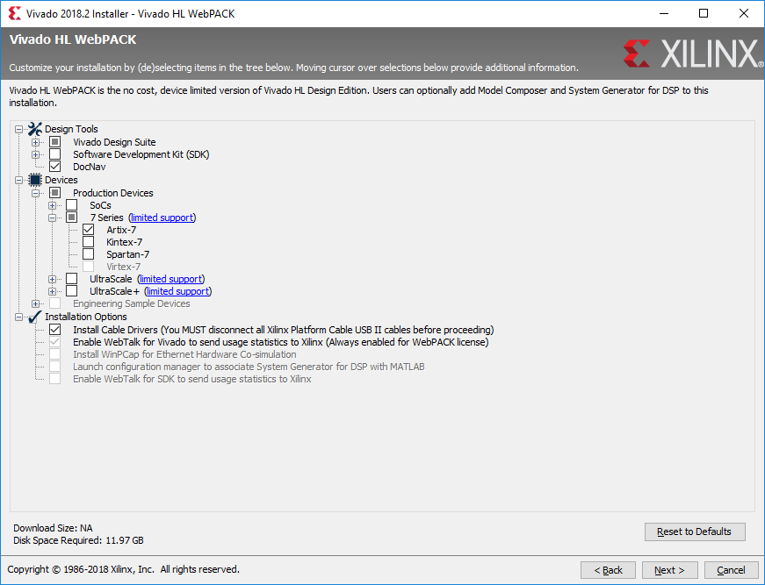

**Only this device family is needed**

**Check SDK (for ECE 383 not ECE 281)** and quietly weep as your HDD space is obliterated

**Select “All users”** for the file associations and click **Next** (does not apply to Vivado upgrade)**.**

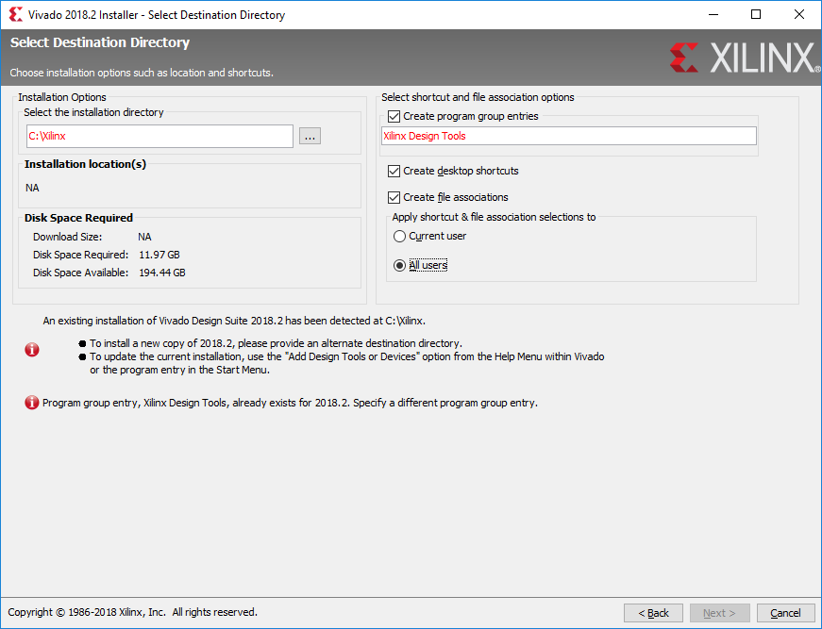

Verify that you are happy with the Installation Summary. It should be similar to the below picture.

Double check that you actually have *at least* the amount of disk space required as indicated in the circled portion of the image below. Maintaining at least 15% free space on your hard drive is ideal.

Click **Install**.

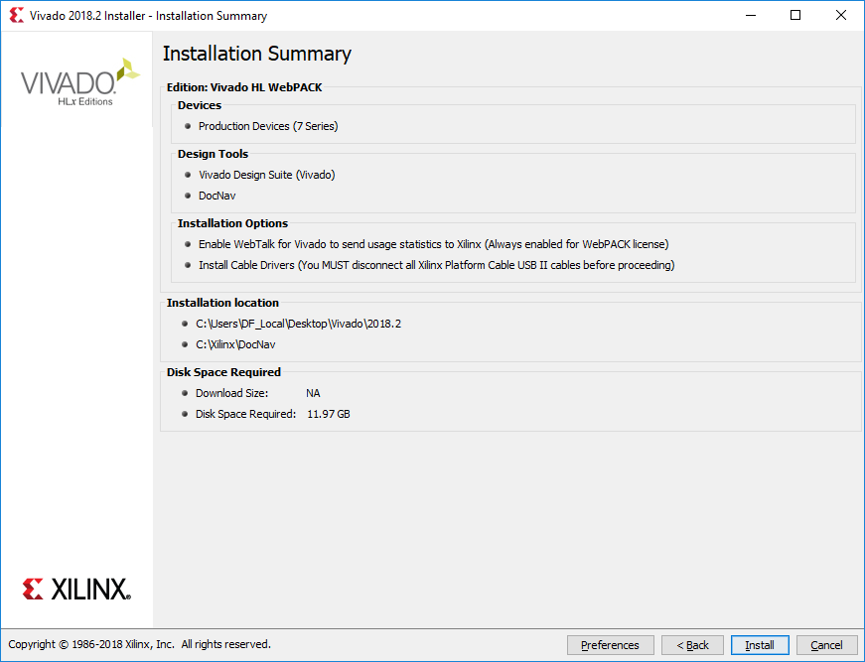

The install will take approximately 20 minutes on a good machine. If you are bored you can watch the adverts during the installation.

**Click OK** that you do not have any cables connected to a FPGA

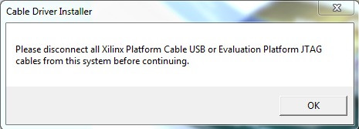

You may see a series of device software popups. **Click Install** for each.

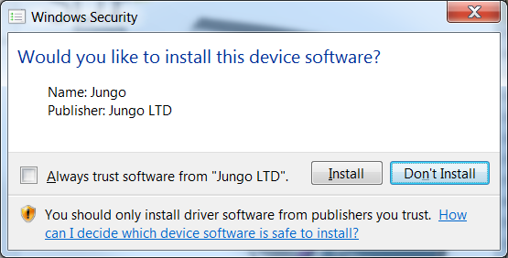

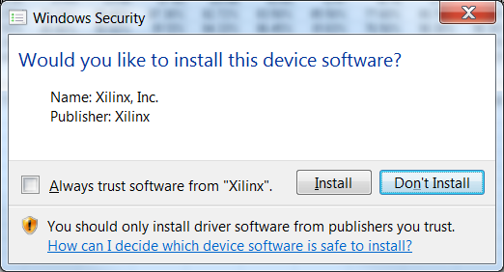

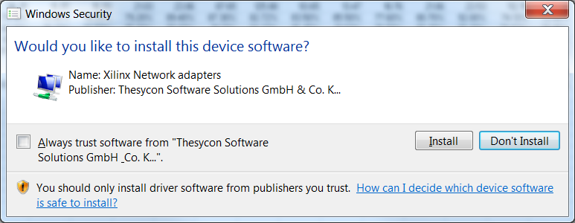

Hopefully you will get a success message that you can click away, and the Vivado license manager should pop up. If the manager does not pop up and doesn’t appear in your start menu, you can create a direct shortcut. Right click on your desk top and select New->Shortcut. For the location of the item paste

C:\Xilinx\Vivado\2018.2\bin\unwrapped\win64.o\vvgl.exe C:\Xilinx\Vivado\2018.2\bin\vlm.bat

If you used a different install location you will have to update the paths to reflect your vivado installation.

Navigate to and select the **Xilinx.lic** file on the provided external hard drive. You can then close the License Manager.

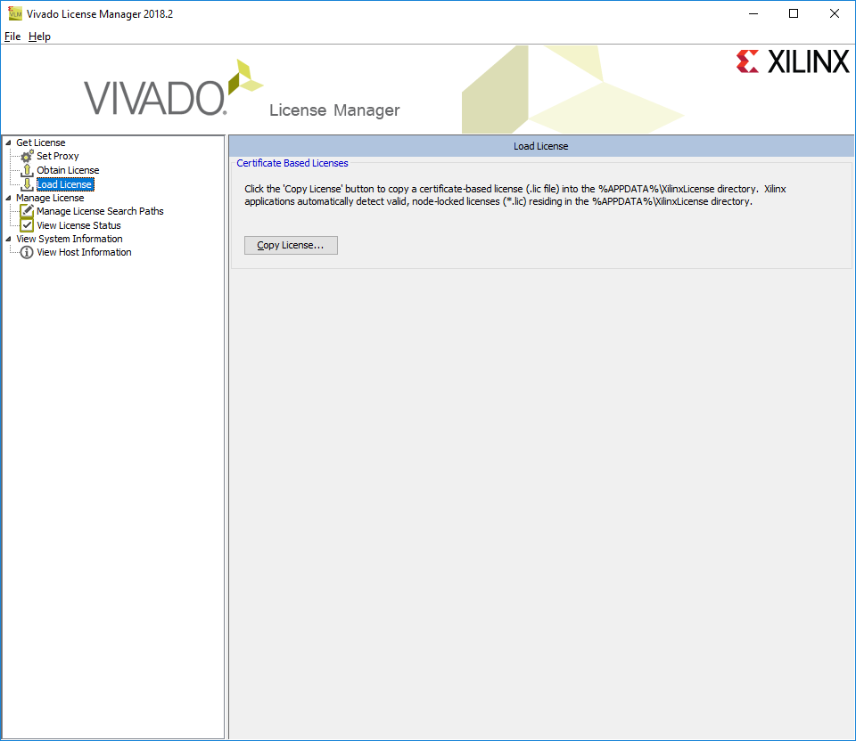

If the shortcut didn’t install and Vivado 2018.2 doesn’t appear in your start menu, you can create a direct shortcut. Right click on your desk top and select New->Shortcut. For the location of the item paste

C:\Xilinx\Vivado\2018.2\bin\unwrapped\win64.o\vvgl.exe C:\Xilinx\Vivado\2018.2\bin\vivado.bat

If you used a different install location you will have to update the paths to reflect your vivado installation.

# Board Support Files Installation

Unzip a copy of vivado-boards-master.zip from a provided external hard drive (or download a new copy from [GitHub](https://github.com/Digilent/vivado-boards/archive/master.zip).

Navigate within the unzipped folder to vivado-boards-master\new\board_files\ and copy the required (or all) of the folders into your Vivado board_files folder at a path similar to: C:\Xilinx\Vivado\2016.4\data\boards\board_files\

Restart Vivado if it was open.

For a more in depth tutorial, see <https://reference.digilentinc.com/reference/software/vivado/board-files>.

CONGRATULATIONS! You have just installed a licensed version of Xilinx Vivado.

You can run it by clicking on the icon that looks like